I used a sample of expression data from the esophagus cancer microarray data. And compared MI-sensitivity group to MI-resistance group to identify the differentially expressed genes.

I first calculated Absent/Present calls to filtered out questionable expressed genes, then calculated the fold change between two groups and used student’s t-test to identify differentially expressed genes.

After the data processing process, I used ggplot to visualize the data. The result is presented as follow:

Boxplot

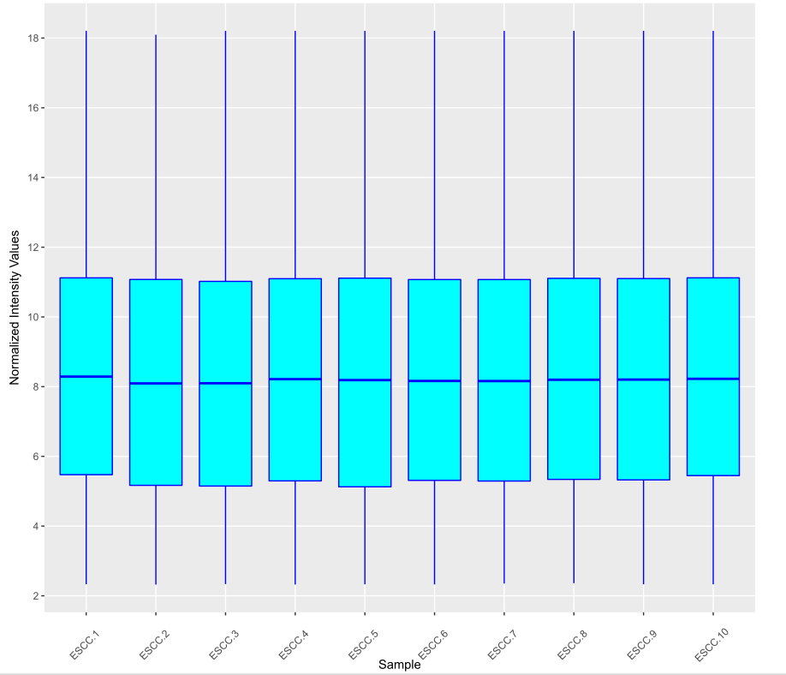

Scatter plot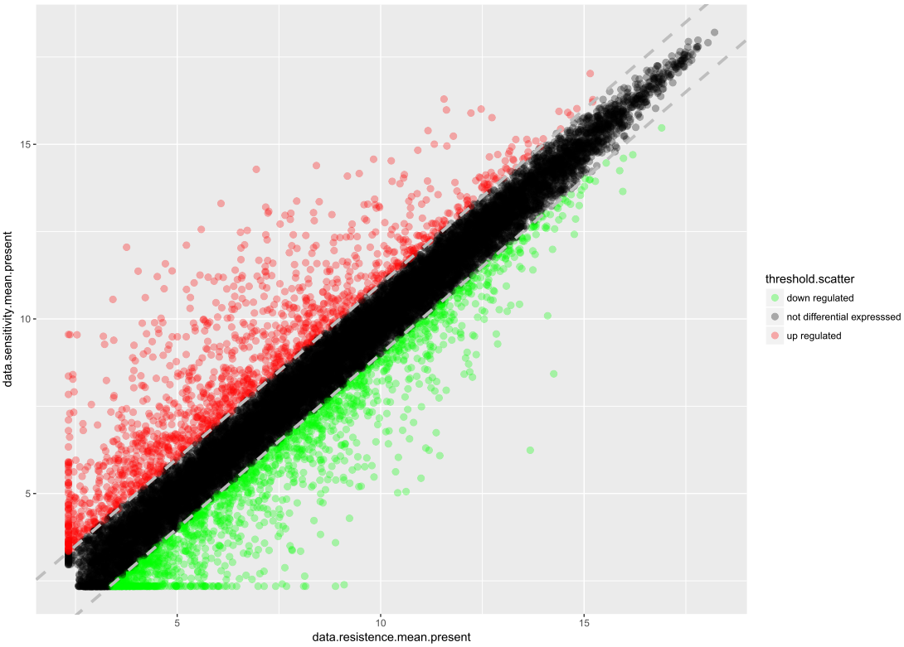

Volcano plot

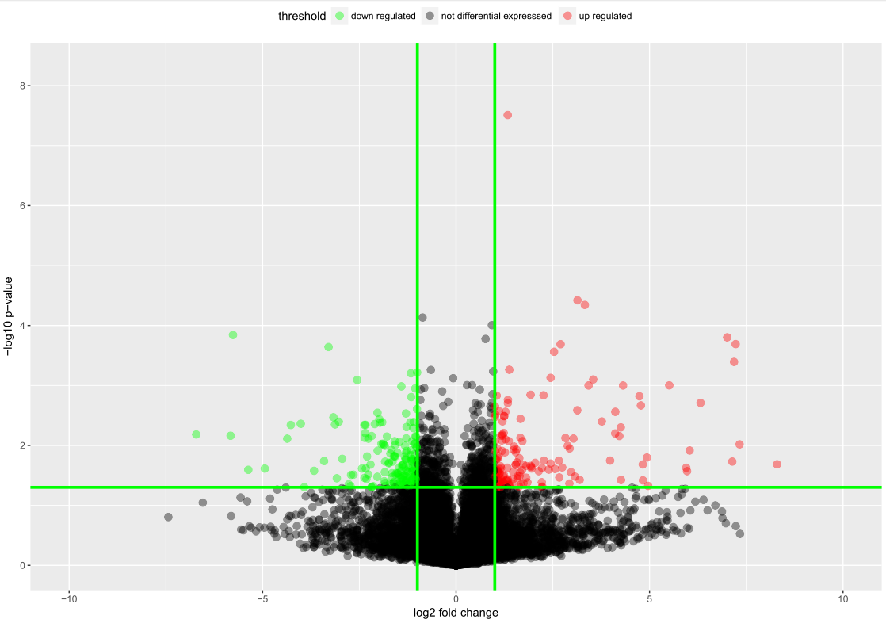

Heatmap for differentially expressed genes

